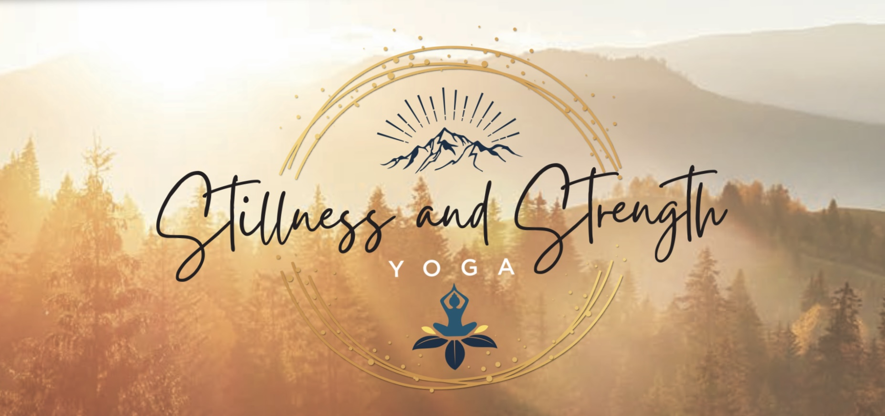
PARTICIPANT AGREEMENT, RELEASE AND ASSUMPTION OF RISK:
Guided Forestbathing Sessions
Name of Participant: ____________________________________________________________
Date of Program: _______________________________________________________________
In consideration of the services of Kristen Ryder/Stillness & Strength Yoga, LLC, their agents, owners, officers, volunteers, participants, employees, and all other persons or entities acting in any capacity on their behalf, I hereby agree to release, indemnify, and discharge Kristen Ryder/Stillness & Strength Yoga, LLC, on behalf of myself, my spouse, my children, my parents, my heirs, assigns, personal representative and estate as follows:
- I acknowledge that outdoor activities in natural areas entail known and unanticipated risks that could result in physical or emotional injury, paralysis, death, or damage to myself, to property, or to third parties. I understand that such risks simply cannot be eliminated without jeopardizing the essential qualities of the activity.
The risks include, among other things: Slipping and falling; falling objects; water hazards; exhaustion; exposure to temperature and weather extremes which could cause hypothermia, hyperthermia (heat related illnesses), heat exhaustion, sunburn, dehydration; and exposure to potentially dangerous wild animals, insect bites, and hazardous plant life; accidents or illness can occur in remote places without medical facilities and emergency treatment or other services rendered; consumption of food or drink; equipment failure; improper lifting or carrying; my own physical condition, and the physical exertion associated with this activity.
Furthermore, Kristen Ryder/Stillness & Strength Yoga, LLC employees have difficult jobs to perform. They seek safety, but they are not infallible. They might be unaware of a participant's fitness or abilities. They might misjudge the weather or other environmental conditions. They may give incomplete warnings or instructions, incorrect information, and the equipment being used might malfunction.
- I expressly agree and promise to accept and assume all of the risks existing in this activity. My participation in this activity is purely voluntary, and I elect to participate in spite of the risks.
- I hereby voluntarily release, forever discharge, and agree to indemnify and hold Kristen Ryder/Stillness & Strength Yoga, LLC from any and all claims, demands, or causes of action, which are in any way connected with my participation in this activity or my use of Kristen Ryder/Stillness & Strength Yoga, LLC equipment or facilities, including any such claims which allege negligent acts or omissions of Kristen Ryder/Stillness & Strength Yoga, LLC.
- Should Kristen Ryder/Stillness & Strength Yoga, LLC or anyone acting on their behalf, be required to incur attorney's fees and costs to enforce this agreement, I agree to indemnify and hold them harmless for all such fees and costs.
- I certify that I have adequate insurance to cover any injury or damage I may cause or suffer while participating, or else I agree to bear the costs of such injury or damage myself. I further certify that I am willing to assume the risk of any medical or physical condition I may have.

PARTICIPANT AGREEMENT, RELEASE AND ASSUMPTION OF RISK
Page 2

- In the event that I file a lawsuit against Kristen Ryder/Stillness & Strength Yoga, LLC I agree to do so solely in the State of Michigan/Leelanau County and I further agree that the substantive law of that state shall apply in that action without regard to the conflict of law rules of that state. I agree that if any portion of this agreement is found to be void or unenforceable, the remaining portions shall remain in full force and effect.
By signing this document, I acknowledge that if anyone is hurt or property is damaged during my participation in this activity, I may be found by a court of law to have waived my right to maintain a lawsuit against Kristen Ryder/Stillness & Strength Yoga, LLC on the basis of any claim from which I have released them herein. I have had sufficient opportunity to read this entire document. I have read and understood it, and I agree to be bound by its terms.

Signature of Participant _________________________________________________________________________
Print Name____________________________________________________________________________________
If Under 18, Signature of Parent or Legal Guardian:____________________________________________________
Address ________________________________________________________________________________________
Email__________________________________________________________________________________________
Phone _____________________________________________________ Date _______________________________

